Welcome!
Date
Name
Spouse
Address
City
State Zip _________
Email

Please Contact By
❑ Card  Phone  Visit

Telephone Best Time to Call
Home ______________
Work ______________

Guest: First Time Second Time
Are you a church member: yes no
Church
City, State

Circle Appropriate Age/Grade Group(s)
Preschool: Ages: B-1 2-3 4-5
Children: Grades: K 1 2 3 4 5 6
Youth: Grades: 7 8 9 10 11 12

Adults: Ages:18-29 30s 40s 50s 60s+

How did you learn about our church?
Newspaper Friend Yellow Pages Mail
Other

I am a guest of:

New in the Community? Yes No
Names & ages of children at home

Weekly Service & Activity Schedule

January 25, 2015
9:45 a.m. Sunday School
11:00 a.m. Morning Worship Service
6:00 p.m. Evening Worship Service

Week of January 25, 2015

Wednesday 7:00 p.m. Adult Prayer & Bible Study

Upcoming Events
February
1………………………………………………….Kids In Action
8……………………………………………...Business Meeting
12……………………………….…………….Adult Fellowship
15………………………Valentine’s Covered Dish Luncheon
26……………………………………………..Adult Fellowship
27 – 28…………….Women’s Conference – Highland Lakes

All Church members please remain after the worship service today for a few minutes. We will be voting to ask Brother David Marchbanks to be our Interim Pastor while the Pastor Search Committee continues its efforts to find the permanent pastor God has for this church.

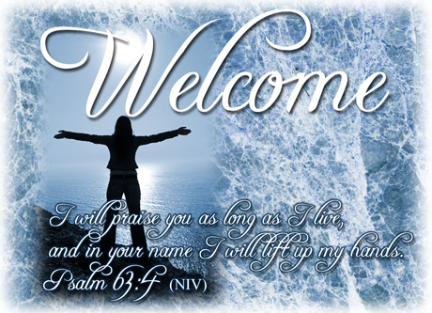

Knobbs Springs Baptist Church

January 25, 2015

Church Information:

KnobbsSpringsBC.com KnobbsSpringsBaptist@gmail.com
1662 CR 305, McDade, Texas 78650 512-273-2743
Patti Radford, Office Manager 512-968-7821

